Habitos Saludable
https://forms.cloud.microsoft/r/1XPPdbyCDp
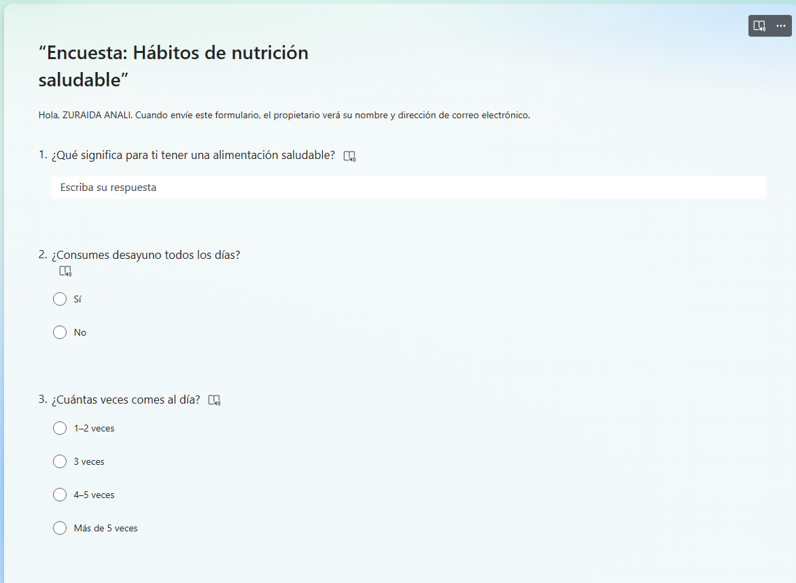
ZURAIDA BERROCAL

